Name of Renter____________________Phone________________
Event Date________________ Event Times___________
Please mark each box when the item is received or completed.
SIGNED CONTRACT

DAMAGE DEPOSIT- DATE PAID, FORM OF PAYMENT AND COPY OF PAYMENT

RENTAL FEE- FORM OF PAYMENT AND COPY OF PAYMENT

Alcohol Permitted No_______ Yes______ (See #12 of Community Center Rental Agreement)

No Tape, Command Strips/Hooks, or thumb tacks to be used on the walls. Pre-hung Command Hooks and Cork strip are available for use.

ACKNOWLEDGEMENT OF CONTRACT BY SIGNEE AND VILLAGE EMPlOYEE

Contract agreement for Harristown Community Center Rental
- Hourly rate for small events is $20.00/hour for Residents of the Village of Harristown, $30.00/hour for Non-residents. Weekday and weekend rates are the same.

- Entire weekend rate (Friday, Saturday, Sunday) $500 Village Resident; $600 Non-resident.

- Non-profit Organizations receive rental at no charge; with approval. (ie; Church, Fire Department, Scout groups, library board, etc.)

- Outside Food or Catering is allowed. Renter accepts all liability with regards to this.

- Strips are provided on the West wall to hang signs. No items are to be pinned, tacked, or taped to walls or doors; Including non-marking command strips.

- Property (ie; Community Center room, kitchen, bathrooms, parking lot & grounds) must be clean; free of trash and debris. This includes emptying all inside garbage containers after rental. All Garbage may be put in Village Garbage bins or recycle bins.

- A Cleaning Fee will be charged if the community center is not properly cleaned. (removing all trash, emptying refrigerator, wiping down tables & counter tops, wiping down bathroom surfaces, placing all tables and chairs on dollies and moved to storage room, vacuum or sweep all areas used)

- A deposit of $150, by signed check, must be left at the time of reservation to cover any damages or cleaning fees.

- All minors must be properly supervised at all times, both inside and outside the building.

- No open flames permitted inside the building. (candles for a birthday cake are the only exception.)

- Any damage to building, furnishings and/or property will be charged to the signer of contract. (repair and/or replacement cost of damaged item)

- Alcohol may only be served in the building, if ALL criteria is met. a. If alcohol is served, the contract signee MUST have proof of insurance covering this occurrence. (This insurance must meet Village of Harristown ordinance requirements all listed in ordinance 21-2-9; see attached copy) b. A temporary liquor license will be required. This is issued by the Village of Harristown with a $50 fee for one day. c. All persons served alcohol must be of legal age. No minor guests shall be served any alcoholic beverages. d. Any person(s) serving alcohol without temporary liquor License shall be subject to a fine of the price of the temporary license ($50) plus a fine of $500.

- A fine of $200 will be assessed for false fire alarms. The alarm equipment is available for emergencies ONLY. Special care should be taken to prevent children playing with this equipment. The Harristown Fire Protection District is notified immediately should this alarm sound.

- Any nuisance or disturbance violations will result in the renters being fined an appropriate cost ($100) and barred from renting the Community Center for a minimum of (1) one year.

- Keys to the building only unlock the Community Center area and are clearly marked DO NOT DUPLICATE. Loss of a key will result in a fee of $100 charged to the contract signee for key replacement costs.

- All damage, cleaning, lost key, fines, or false fire alarm fees are due and payable upon receipt of a bill from the Village of Harristown. Should legal action be required to collect these fees, all additional legal fees will be paid by the contract signee.

Emergency Contacts for the Village of Harristown:
Evelyn Deverell, Mayor 217-972-4215

Les Jenkins, Mayor Pro-tem 217-791-7147

Macon County Sheriff non-emergency 217-424-1319

EMERGENCY ONLY 911

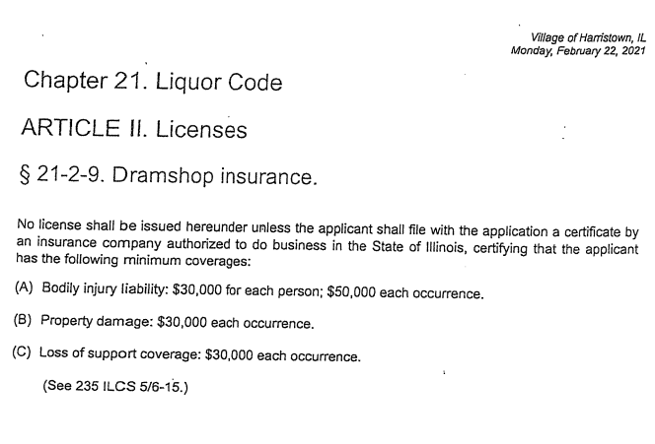

- Clean off and wipe down ALL tables.
- Clean and wipe down ALL chairs.
- Put away all chairs and push tables against walls; unless previously asked otherwise.
- Sweep and mop floor if needed; broom and mop are in the tables and chair closet.
- Take out all garbage from both restrooms
- Clean kitchen if used:
__Wipe off all counter tops
__Sweep and mop floor
__Clean out all your items from refrigerator and freezer
__Clean out sink if used
__Take out garbage
- Any garbage left outside MUST be put in garbage cans on the south side of the building.

I, ________________________ acknowledge that all items on this list have been completed and the Community Center is left in the same condition as when I arrived. I understand that failure to complete all items on this list could result in my deposit not being refunded and used as a cleaning fee.

I __________________________________, agree to the terms of the attached contract. I further agree to pay the amount of $__________ as a rental fee for the use of the Harristown Community Center on Date:_________Time:________. A damage deposit fee of $150 has been paid by:
Check #__________, Money order, or Cash.

Person responsible for key, payment, and damages:
Signature___________________ Printed Name:___________________
Address:____________________________________________________
Phone:_____________________ Email:__________________________

Village Resident

Non-Resident

______________________________________________
Harristown Village Representative Signature

