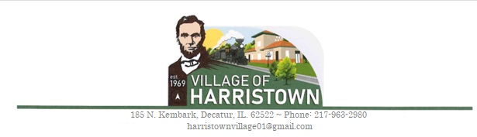
VILLAGE NUISANCE COMPLAINT FORM
Please complete the following form so that the Village can properly investigate and determine if action needs to be taken.
Name of Complainant:________________________________________ Date:__________________________
Address:______________________________________ Phone Number:_____________________________

Circle nature of complaint(s) :
- Building/Unsafe Structure
- Junk Vehicles
*Code/Ordinance Section:_________________________
- Garbage/Offensive Smell
- Junk in Yard
- Fence
- Weeds/Overgrowth/Trees/Grass
- Animal complaint
- Signage or Right of way use
- Other _________________________________________________________________________________
Address of alleged nuisance:__________________________________________________________________
Have you attempted to discuss the issue with the other person, neighbor, or animal/property owner? _________
Description of violation/ nature of complaint (Please be sure to include as much detail as possible- Location, how long has this been happening, how you feel the nuisance can be corrected ETC. You may use additional sheets of paper if needed.)
__________________________________________________________________________________________________________________________________________________________________________________________________________________________________________________________________________________________________________________________________________________________________________________________________________________________________________________________________________________________________________________________________________________________________________________________________________________________________________________________________________________________________________________________________________________________________________________________________________________________________________
*Please remember that this is a request to have a village official look into the possible violation and that this is not the instructions the Village is required to follow. We will take your resolution into consideration; however, the Village of Harristown reserves the right to resolve any complaint as the Village of Harristown sees fit.
Resident’s Signature:________________________________________________________________________
For Office Use Only:
Date Received:__________________ In Violation: Yes/No Date letter sent:______________
Comments:_______________________________________________________________________________________________________________________________________________________________________________________________________________________________________________________________________________________________________________________
____

