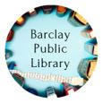
220 S. Main Warrensburg
www.barclaylibrary.org
December 2022
Call 217-672-3621 to register for programs.
Library is CLOSED:
December 23rd – 26th for Christmas
December 30th – January 2nd for New Year’s

Legends of Warrensburg Cemetery Walk
The Cemetery Walk Program had to be rescheduled to spring due to an accident near the cemetery.
Harristown Locker Delivery
We can now deliver your library items to our lockers outside of Harristown Village Hall. If you would like your items delivered, please call 217-672-3621.
The Friends of Barclay Library Cookie Walk
Homemade Cookies $5/lb
Saturday, December 3rd, 9:00 am to Noon
Illini Park Building, 265 S. Main St., Warrensburg
Sign-up sheets are at the library if you would like to donate cookies or volunteer for the Cookie Walk.

Lion’s Club Providing Holiday Meals
If you or a family you know of can benefit from a holiday meal, please call Pat Bales at 217-877-4700.

Toy Drive – Help Community Kids
The Village Hall, the bank in Latham, and the Barclay Public Library are drop off locations for toys. Dollar General is accepting donations of toys purchased at Dollar General. Thank you for caring for our children!

KIDS & TEENS
Storytime
Tuesdays at 10:30 am
Join us at the library each Tuesday morning for a new story and craft! Storytime is a first step toward building literacy and social skills for your child. No registration required.
Music Makers
0-4 years old (Older siblings welcome)
Fridays at 10:30 am
Bring your little ones to make music each Friday! Join us in singing songs and playing instruments! No registration required.

Cookies & Cocoa & Crafts
Saturday, December 17th at 11am
Make your own festive Christmas decorations and enjoy cookies and cocoa! We will provide supplies to make a variety of Christmas ornaments. No registration required.
Proofreading Help for Students
Are you a student in grades 8-12 who would like someone to proofread your writing assignment? We can help you make those final corrections. Send an email to dmoore@barclay.lib.il.us to schedule time on a Tuesday or Thursday evening. Be sure to bring a paper or digital copy of your draft.
ADULTS
Coffee Club
Wednesdays 9:30am
Stop by the library for coffee and conversation!
Second Saturday Book Club
Saturday, December 10th 11:00am
Same Kind of Different as Me by Ron Hall and Denver Moore. This true story describes how the lifelong friendship between Denver Moore, a homeless man, and Ron Hall, a wealthy art dealer, came to be.

Gingerbread House Contest – Families Welcome!
Thursday, December 15th at 6 pm
Join us to make gingerbread houses and then enter the gingerbread house contest at Barclay Public Library. Register quickly to reserve one of the 15 houses we’ll provide or bring your own. Houses come with basic decorations but you can bring additional decorations if you would like. Gingerbread houses will be on display in the library for a week while people vote on them. The winner will receive a $25 gift card to 121 Coffee Run.
New Library Cards for Veterans  New library cards are now available for our patrons who are veterans. These new cards were purchased by the Don Craig Memorial Fund. | 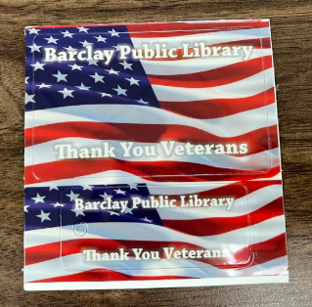

Person of the Month –Brittany Wentworth for helping with Story Time.

Digital Library Services – FREE – available at www.barclaylibrary.org
- Libby– large selection of audiobooks and ebooks!
- CloudLibrary – large selection of ebooks!
- Hoopla –Audiobooks, ebooks, movies, magazines, courses, and even music and TV shows!
- Kanopy – large selection of movies for both children and adults!
- Reference Solutions – Create marketing lists, find people, and learn about businesses.

